Gayathri.P
192424324

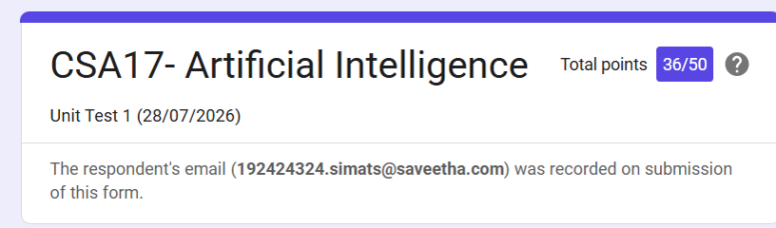

SIMATS ENGINEERING

SAVEETHA INSTITUTE OF MEDICAL AND TECHNICAL SCIENCES
DEPARTMENT OF COMPUTER SCIENCE AND ENGINEERING

CO1 – ASSESSMENT TOOL 3

Descriptive Written Test

COURSE NAME: Artificial Intelligence COURSE CODE: CSA17
QUESTIONS: 2 Duration: 45 Minutes Total Marks: 20
RUBRICS:
Criteria | Weightage | Q1 (10) | Q2 (10) | Total Marks (20)
Understanding of Concepts | 25% (2.5) | 2.0/2.5 | 2.0/2.5 | 4/5
Explanation | 25% (2.5) | 2.0/2.5 | 2.0/2.5 | 4/5
Application | 20% (2) | 1.5/2 | 1.5/2 | 3/4
Organization | 15% (1.5) | 1.0/1.5 | 1.0/1.5 | 2/3
Accuracy | 10% (1) | 1.0/1 | 1.0/1 | 2/2
Clarity | 5% (0.5) | 0.5/0.5 | 0.5/0.5 | 1/1
Total per Question | 10 Marks | 8/10 | 8/10 | 16/20

